**Car Sales 2014 Report**

* *Top Driver By Miles :*

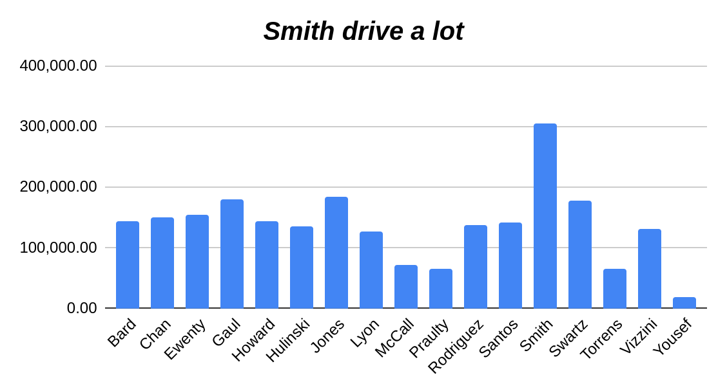

* *Scatter Plot For the Car Inventory Age & Miles:*

